**DATA ANALYSIS USING EXCEL(SALES TRACKER**)

Submitted by

Manoj kumar Pidugu(MSS2021041)

Graduating in

**LOYOLA ACADEMY**

Submitted to

**Medha Charitable Trust**

**Introduction**

A sales tracker is a tool used to monitor and analyze sales data over time. It allows businesses to track key metrics such as sales revenue, quantity sold, product performance, and regional sales trends of nearby store Rathna deep. By organizing and visualizing this data, organizations can gain valuable insights into their sales operations and identify areas for improvement.

**Problem statement**

Sales Tracker used to build a sales tracker to monitor product sales over time, analyze trends, and compare performance among different persons or product categories. Visualize data with charts to identify opportunities for growth.

Technologies involved

**MS EXCEL**

**IMPLEMENTATION**

I took the data of 40 customers of Rathnadeeep store who filled the questionnaire. the collected original data

The data have sorted using the sort function by the name according to alphabetical order

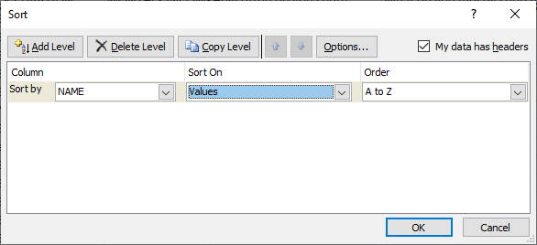

**Using countif()**

* Calculated no of men visited the store using count if function:15
* Women: Total-no of men=25
* No.of students:27
* No of business men:1
* Others:12
* No of persons visiting weekly once:17
* No of persons visiting monthly once:18
* No of persons visiting for groceries:28
* No of persons visiting for the vegetables:6

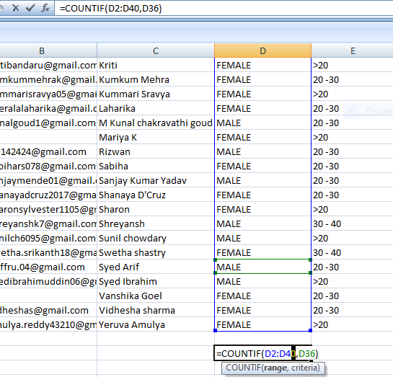

**Graphical Representations**

Pie chart that represents the no of men and women visited the store

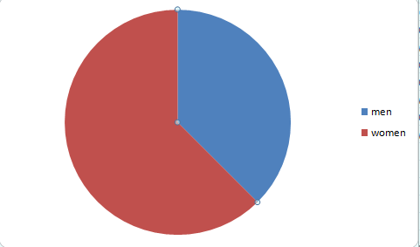

**How often do you visit shop?**

**What do you mostly shop for at RATNADEEP store?**

**What is your Preference of shopping**

**Which form of advertisement do you think is most effective?**

If **you are to rate your experience shopping at RATNADEEP, it would be**

**Rating out of 5**

Verified whether all blanks are filled or not in monthly income using **countblank() function**

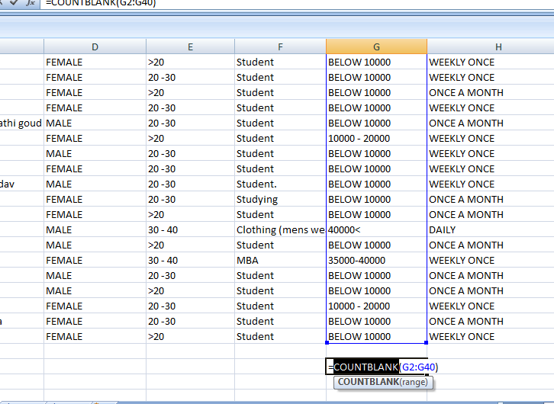

* 2 members are not filed the monthly income.

**Conclusion:**

In, conclusion this project gives the idea about interest of the customers. We can efficiently track the sales, different type of the customers are coming to the store. To increase the sales the change the store the according to the comfort of the customers, make available of the products in which customers are more interested.